Module:2

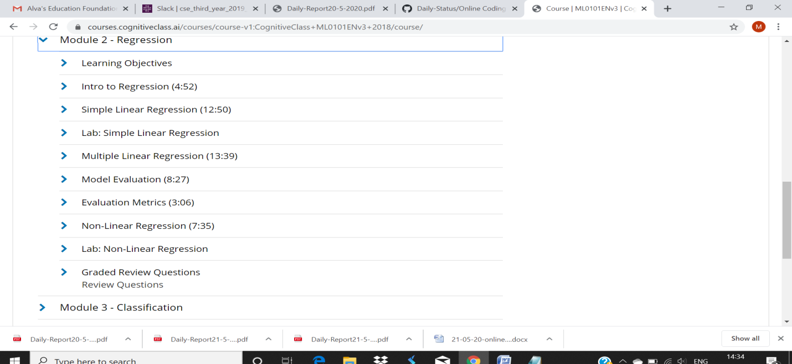

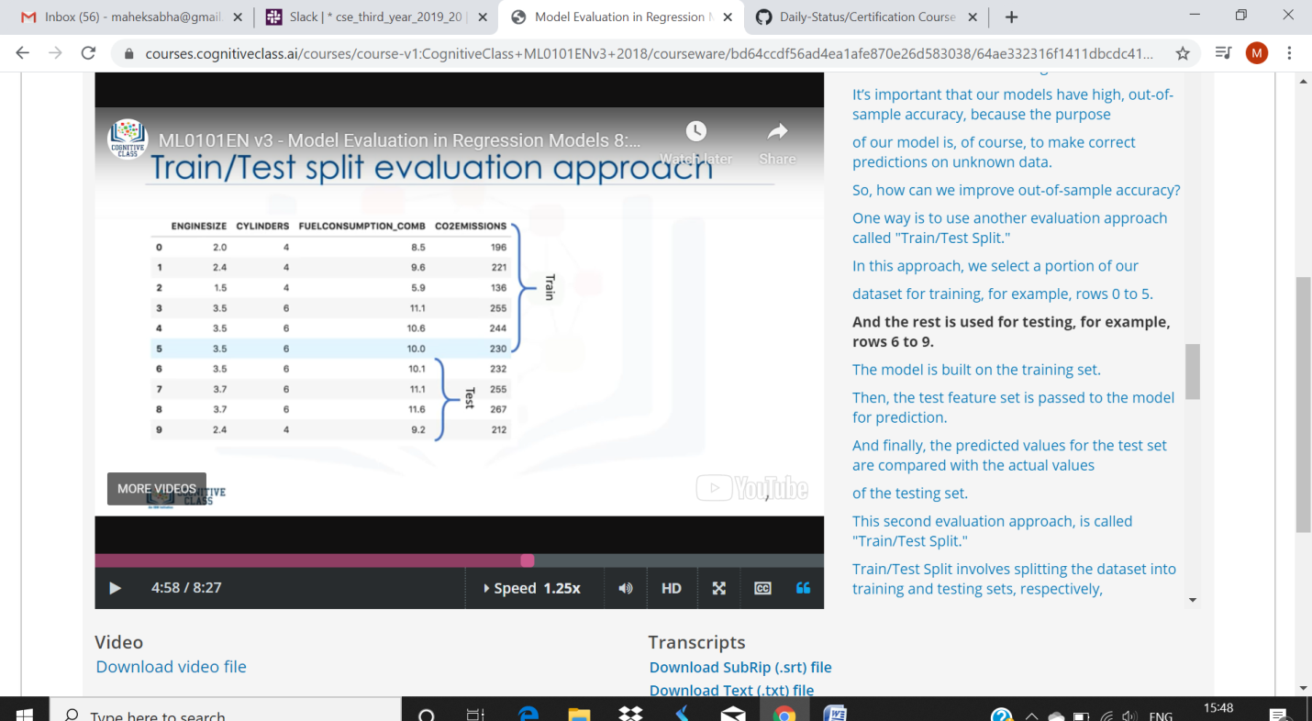

 After building a number of different regression models, there is a wealth of criteria by which they can be evaluated and compared. Root Mean Squared Error. RMSE is a popular formula to measure the error rate of a regression model.

This was finally to test the split involves splitting the satatest.